**SQL TASK 1**

**MANIKANDAN R**

**B53WDT**

**SQL Lesson 1: SELECT queries:**

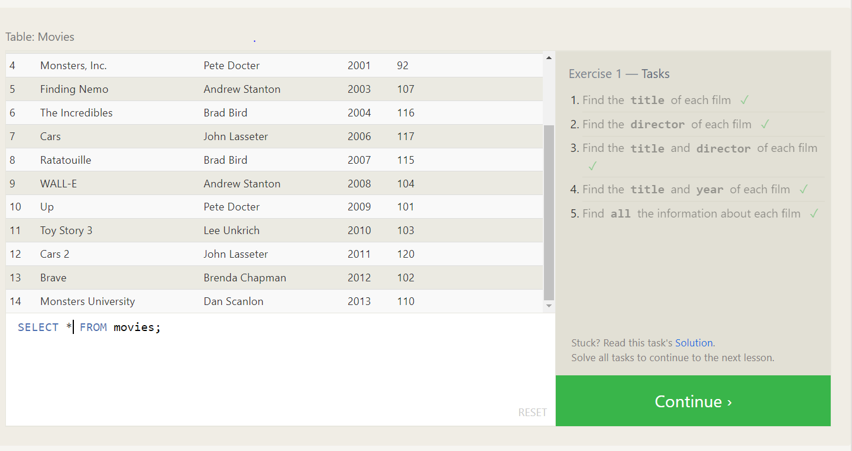

1.SELECT title from movies;

2.SELECT director from movies;

3.SELECT title,director from movies;

4.SELECT title,year from movies;

5.SELECT * from movies;

**SQL Lesson 2: Queries with constraints:**

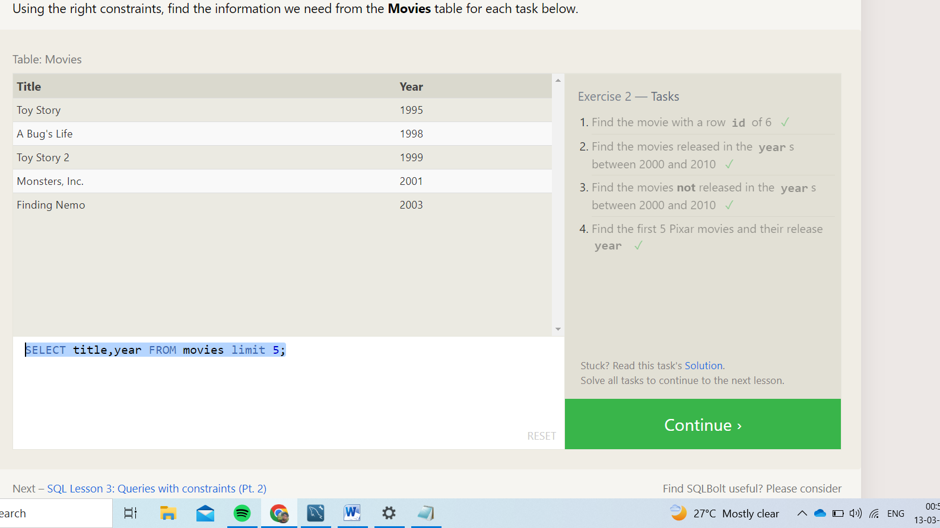

1.SELECT * FROM movies where id = 6;

2.SELECT * FROM movies where year between 2000 and 2010;

3.SELECT * FROM movies where year not between 2000 and 2010;

4.SELECT title,year FROM movies limit 5;

**SQL Lesson 3: Queries with constraints**

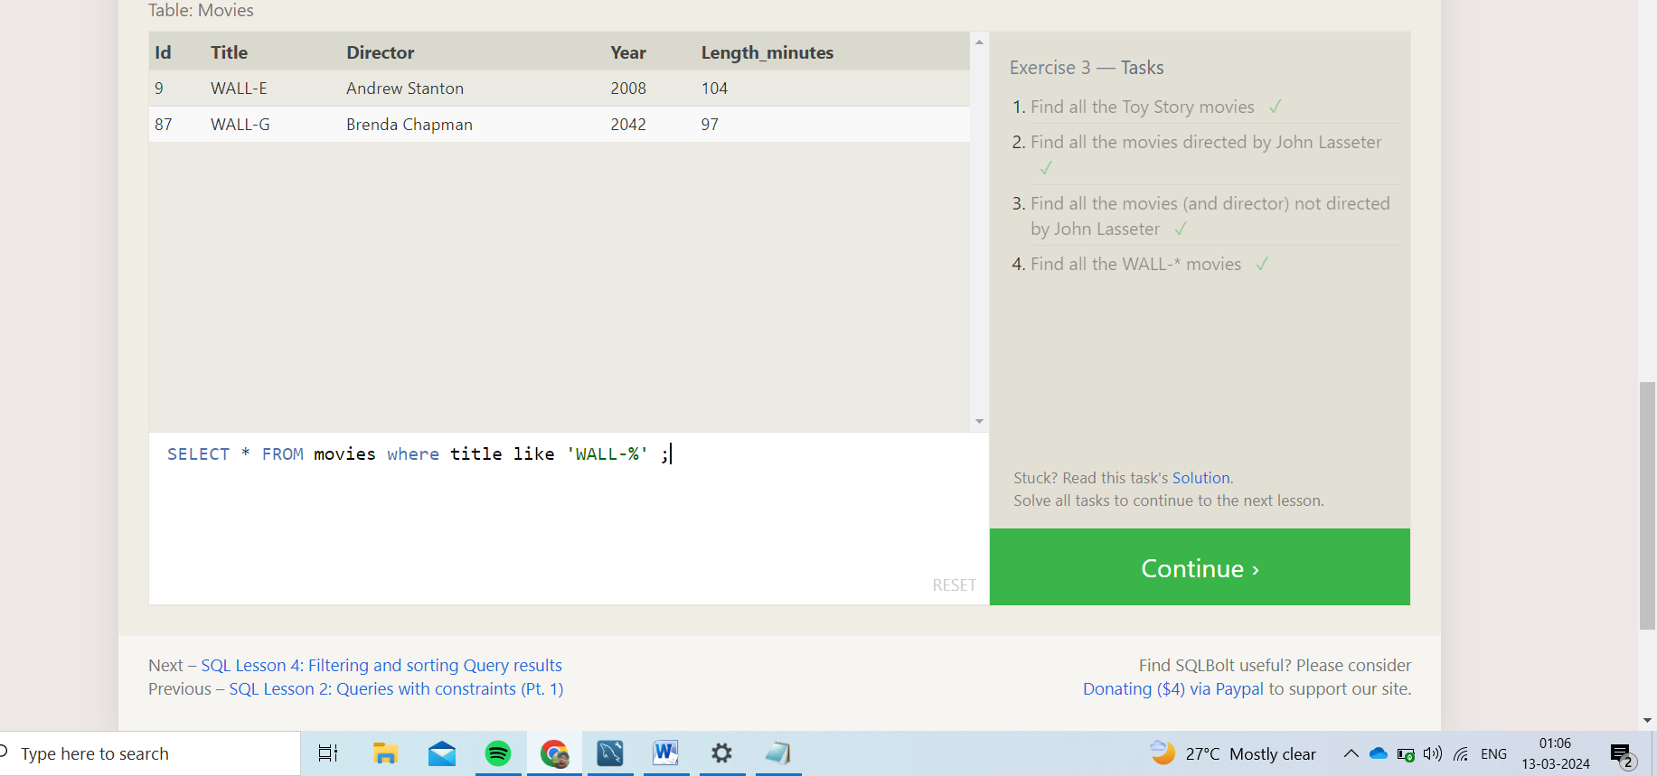

1.SELECT * FROM movies where title like "Toy Story%";

2.SELECT * FROM movies where director = 'John Lasseter';

3.SELECT * FROM movies where director != 'John Lasseter';

4.SELECT * FROM movies where title like 'WALL-%' ;

**SQL Lesson 4: Filtering and sorting Query results:**

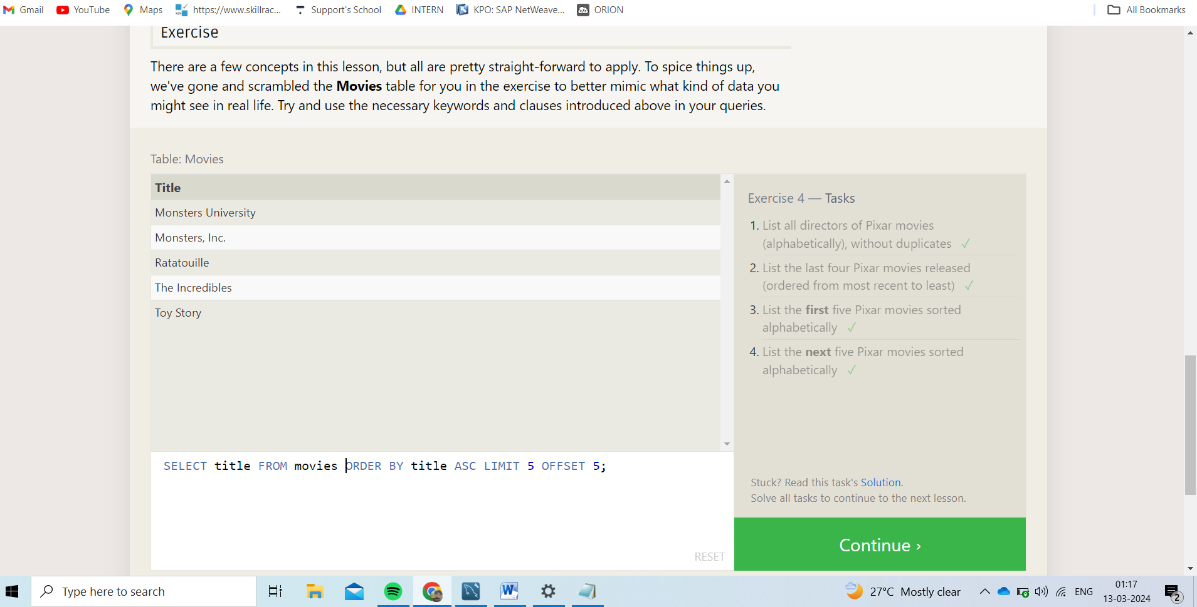

1.SELECT distinct(director) FROM movies order by director;

2.SELECT title from movies order by year desc limit 4;

3.SELECT title from movies order by title limit 5;

4.SELECT title FROM movies ORDER BY title ASC LIMIT 5 OFFSET 5;

**SQL Review: Simple SELECT Queries:**

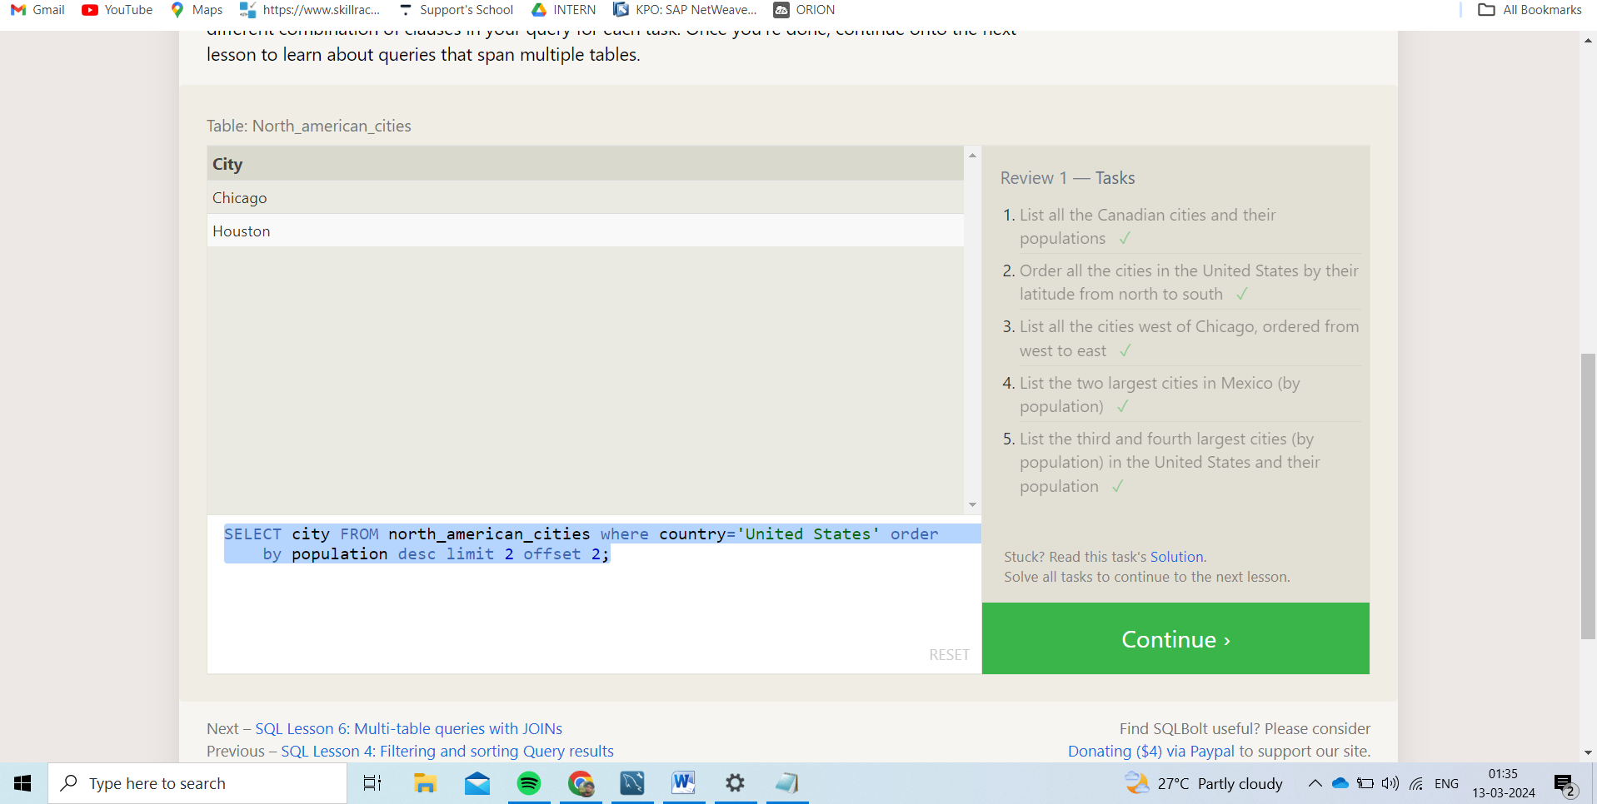

1.SELECT city,population FROM north_american_cities where country = "Canada";

2.SELECT CITY FROM north_american_cities where country = "United States" ORDER BY LATITUDE DESC;

3.SELECT city, longitude FROM north_american_cities WHERE longitude < -87.629798 ORDER BY longitude ASC;

4.SELECT city FROM north_american_cities where country='Mexico' order by population desc limit 2;

5.SELECT city FROM north_american_cities where country='United States' order by population desc limit 2 offset 2;

**SQL Lesson 6: Multi-table queries with JOINs**

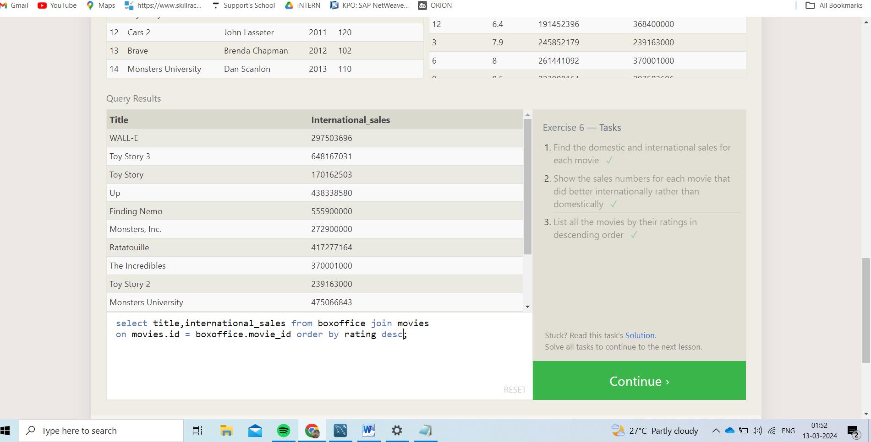

1.select title,domestic_sales,international_sales from boxoffice join movies on movies.id = boxoffice.movie_id;

2.select title,domestic_sales,international_sales from boxoffice join movies on movies.id = boxoffice.movie_id where international_sales > domestic_sales;

3.select title,international_sales from boxoffice join movies on movies.id = boxoffice.movie_id order by rating desc;

**SQL Lesson 7: OUTER JOINs:**

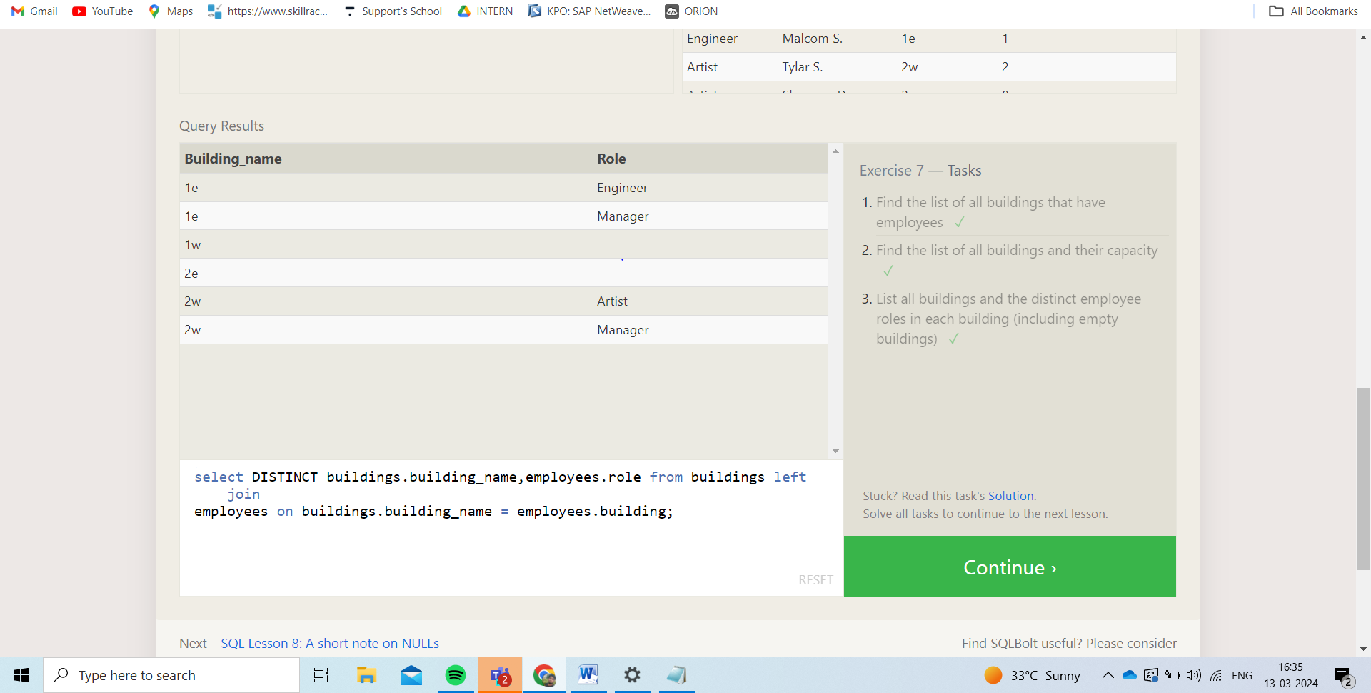

1.SELECT distinct(buildings.building_name)FROM employees join Buildings on buildings.Building_name = employees.Building;

2.SELECT building_name,capacity FROM Buildings;

3.select DISTINCT buildings.building_name,employees.role from buildings left join employees on buildings.building_name = employees.building;

**SQL Lesson 8: A short note on NULLs:**

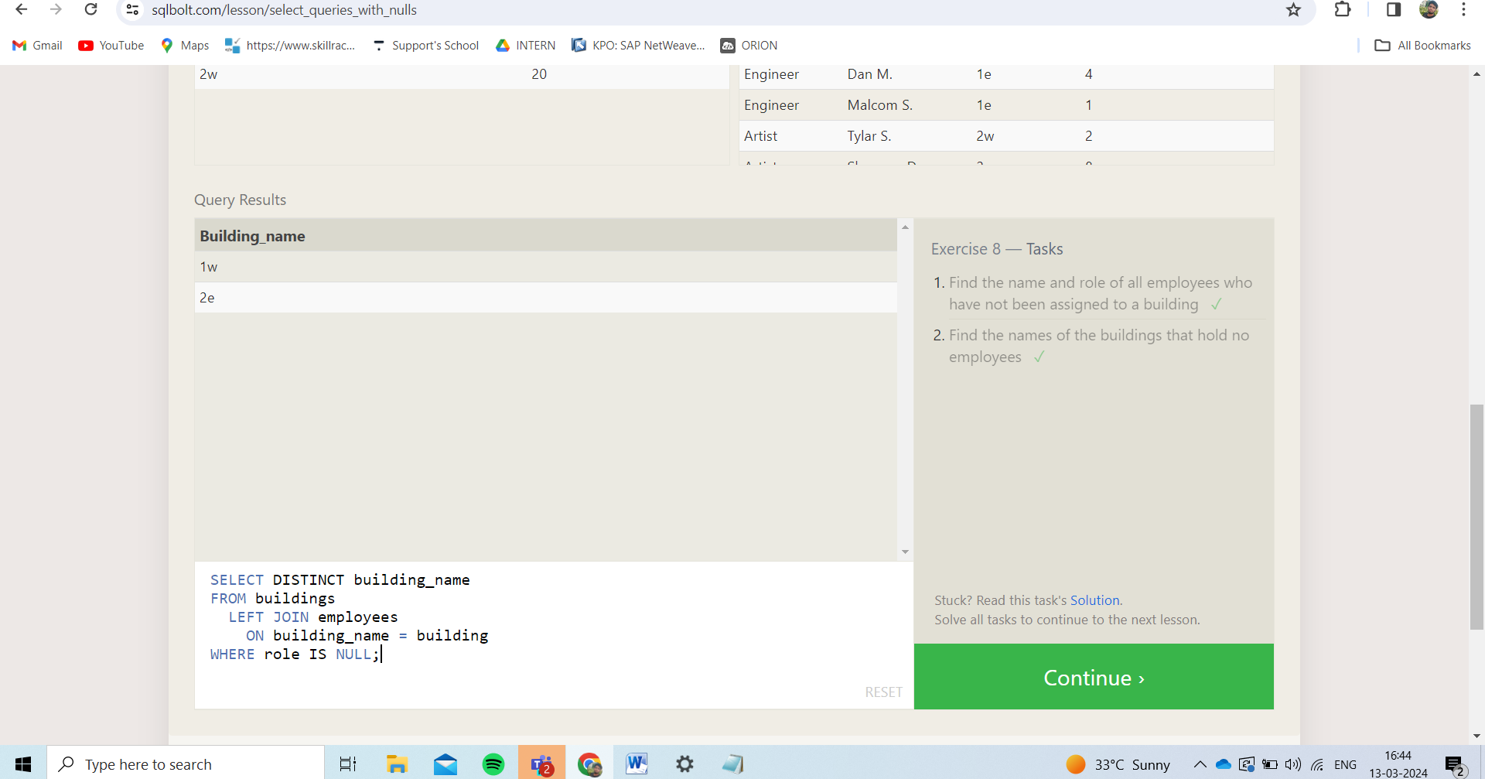

1.SELECT name,role FROM employees where building is null ;

2.SELECT DISTINCT building_name FROM buildings LEFT JOIN employees ON building_name = building WHERE role IS NULL;

**SQL Lesson 9: Queries with expressions:**

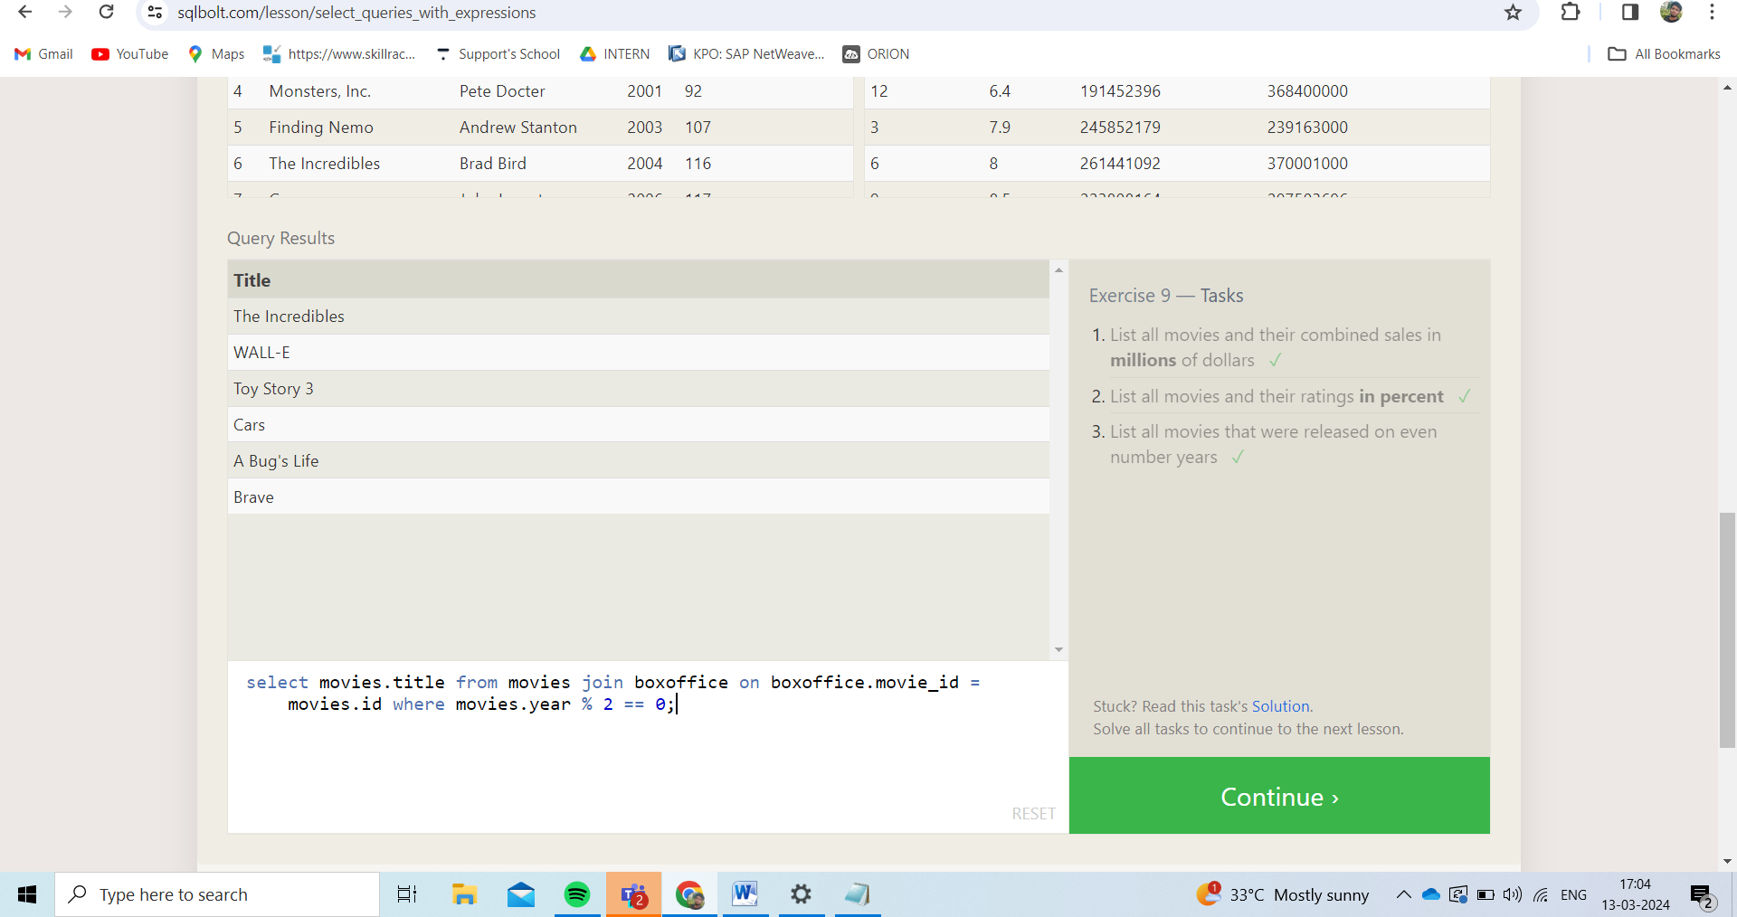

1.SELECT title,(boxoffice.international_sales+boxoffice.domestic_sales)/1000000 as combined_sales FROM movies join boxoffice on movies.id = boxoffice.movie_id;

2.select movies.title,boxoffice.rating*10 as rating_in_percentage from movies join boxoffice on movies.id=boxoffice.Movie_id;

3.select movies.title from movies join boxoffice on boxoffice.movie_id = movies.id where movies.year % 2 == 0;

**SQL Lesson 10: Queries with aggregates:**

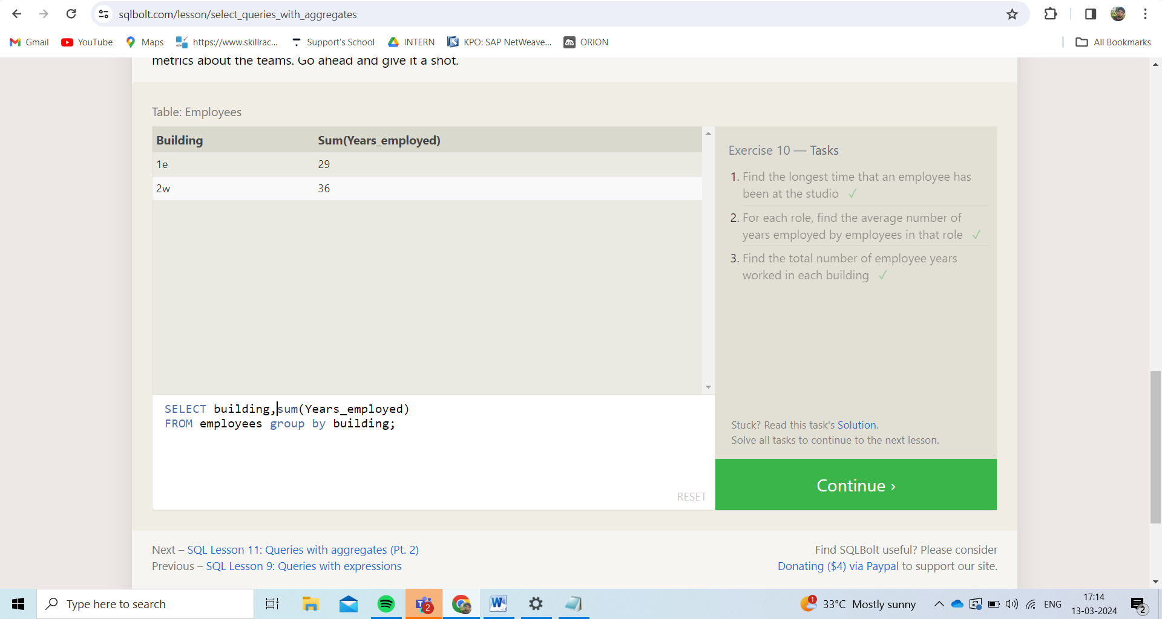

1.SELECT max(Years_employed),name FROM employees;

2.SELECT role, AVG(years_employed) as Average_years_employed FROM employees GROUP BY role;

3.SELECT building,sum(Years_employed) FROM employees group by building;

**SQL Lesson 11: Queries with aggregates:**

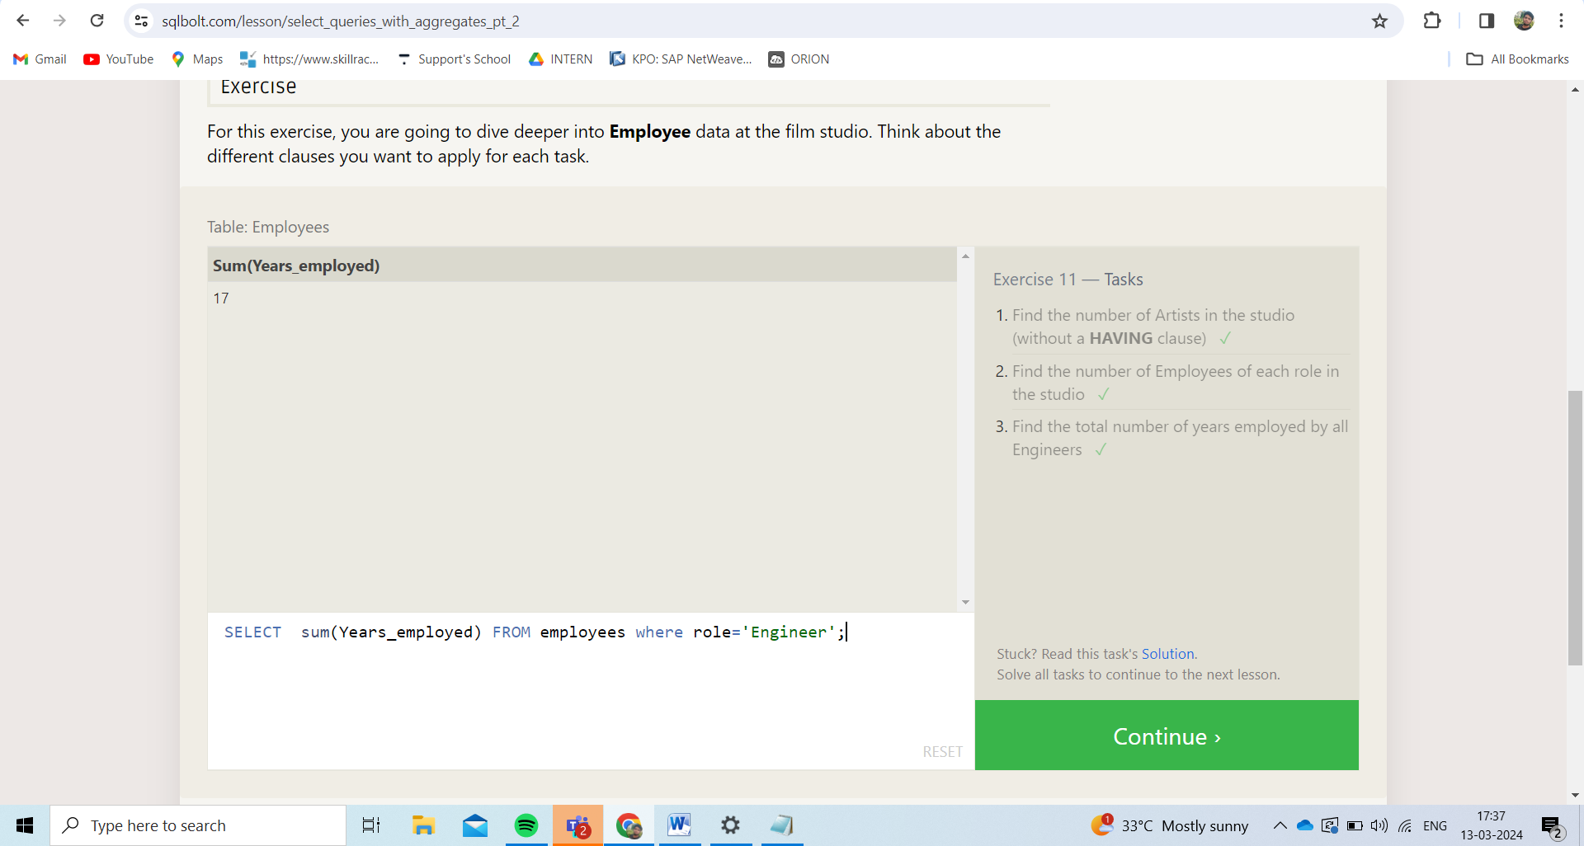

1. SELECT count(role) FROM employees where role = 'Artist';
2. SELECT role,count(name) FROM employees group by role;
3. SELECT sum(Years_employed) FROM employees where role='Engineer';

**SQL Lesson 12: Order of execution of a Query:**

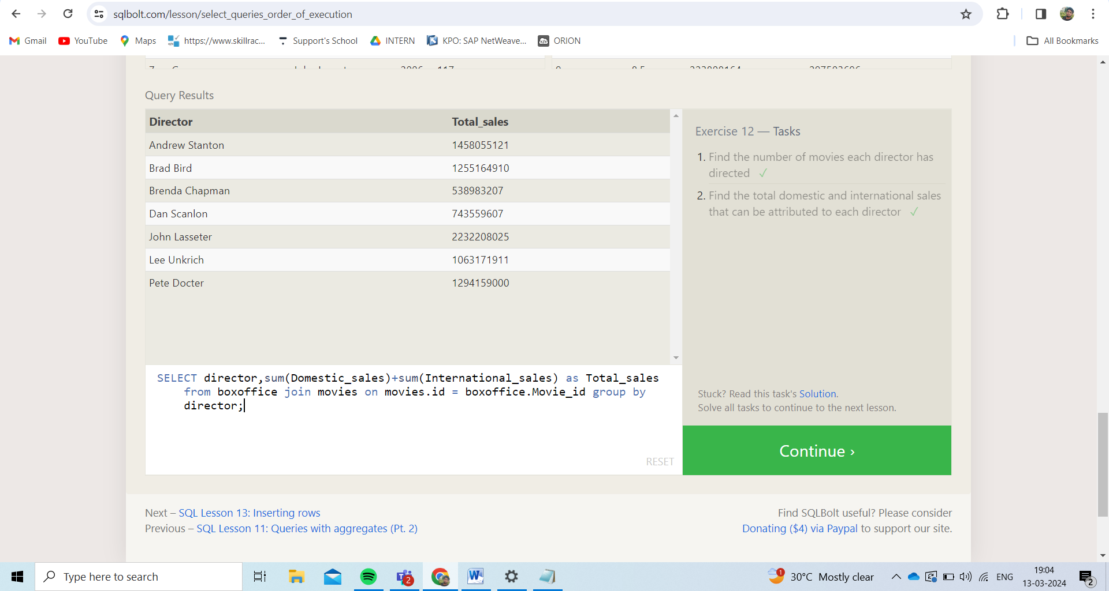

1.SELECT director,count(director) FROM movies group by director;

2. SELECT director,sum(Domestic_sales)+sum(International_sales) as Total_sales from boxoffice join movies on movies.id = boxoffice.Movie_id group by director;

**SQL Lesson 13: Inserting rows:**

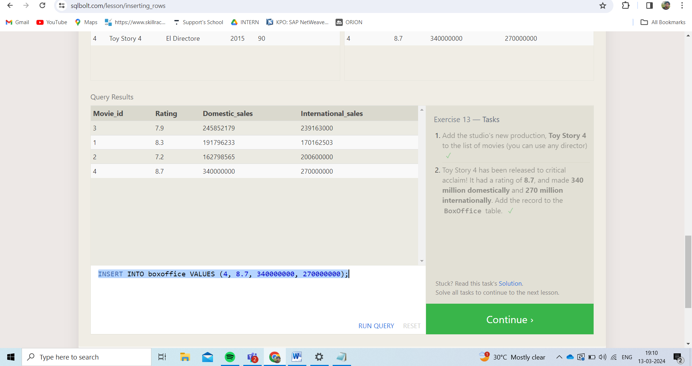

1. INSERT INTO movies VALUES (4, "Toy Story 4", "El Directore", 2015, 90);
2. INSERT INTO boxoffice VALUES (4, 8.7, 340000000, 270000000);

**SQL Lesson 14: Updating rows:**

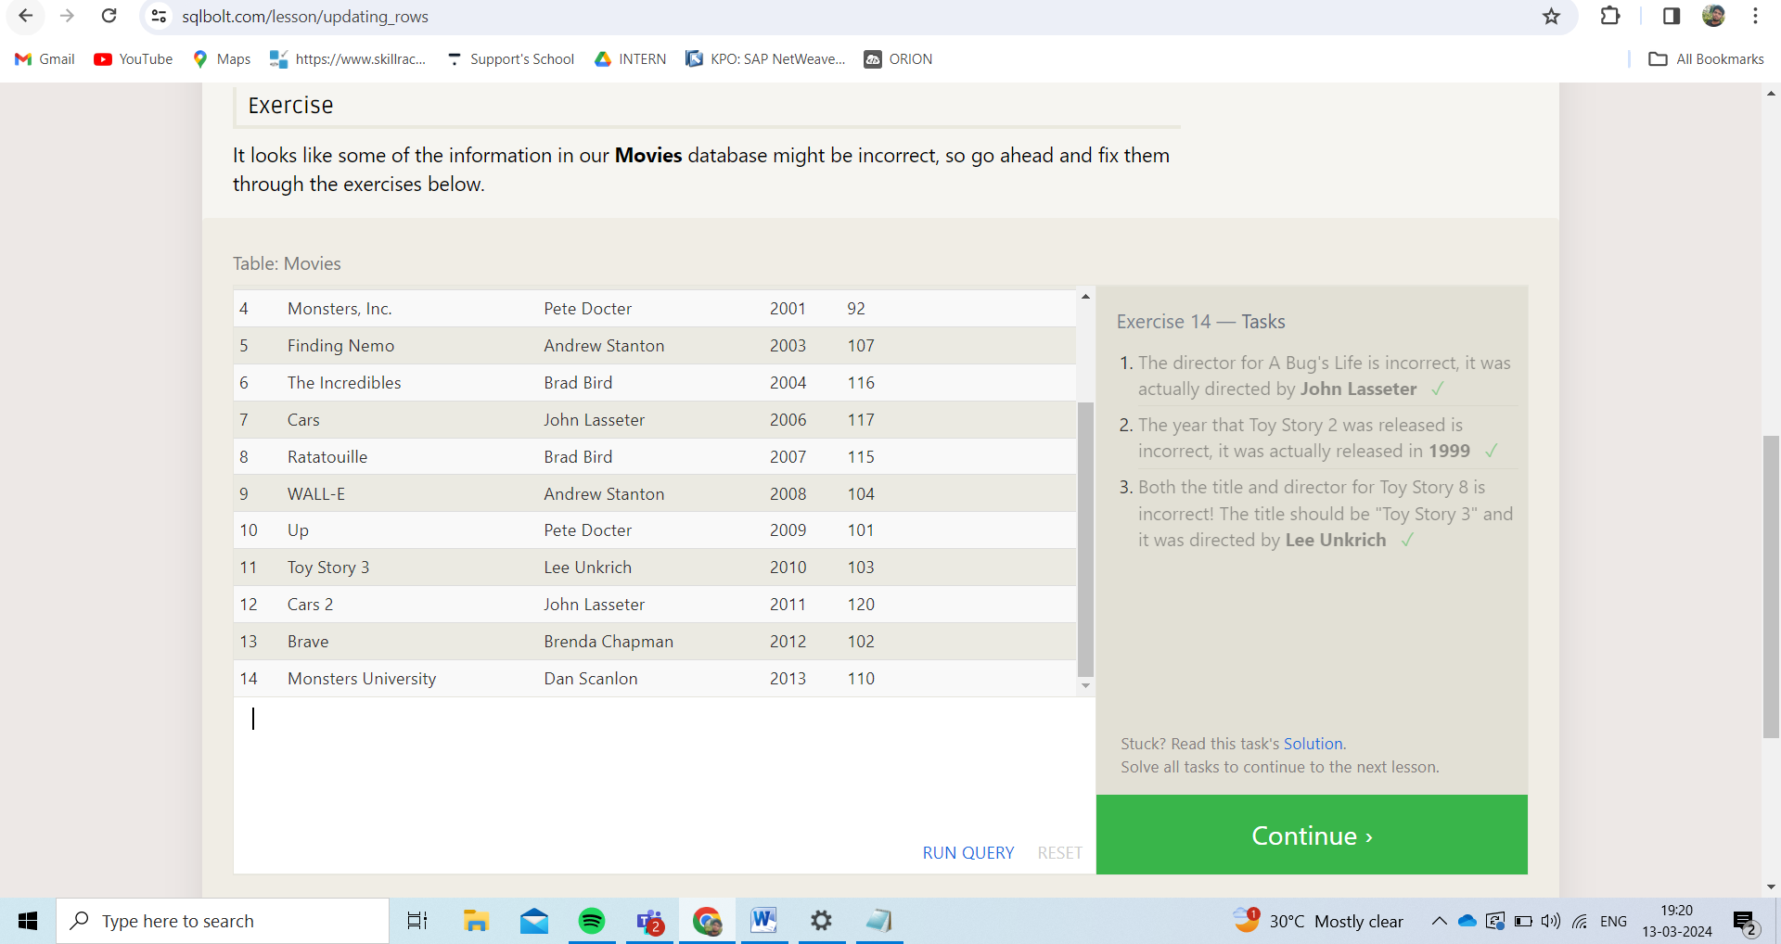

1.update movies set Director = 'John Lasseter' where title = "A Bug's Life";

2.update movies set year = '1990' where title = 'Toy Story 2';

3.update movies set title = 'Toy Story 3',Director = 'Lee Unkrich' where title = 'Toy Story 8';

**SQL Lesson 15: Deleting rows:**

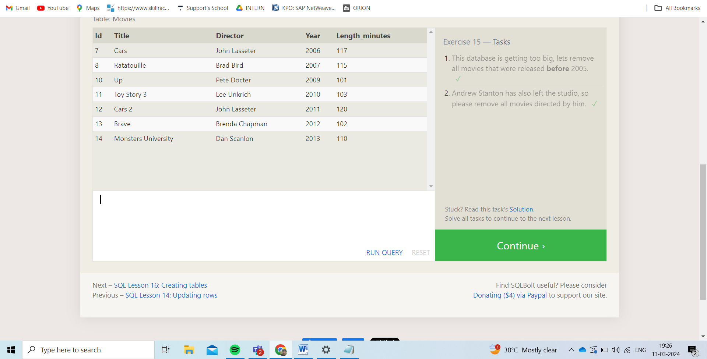

1.Delete from movies where year<2005;

2. Delete from movies where director ='Andrew Stanton';

**SQL Lesson 16: Creating tables:**

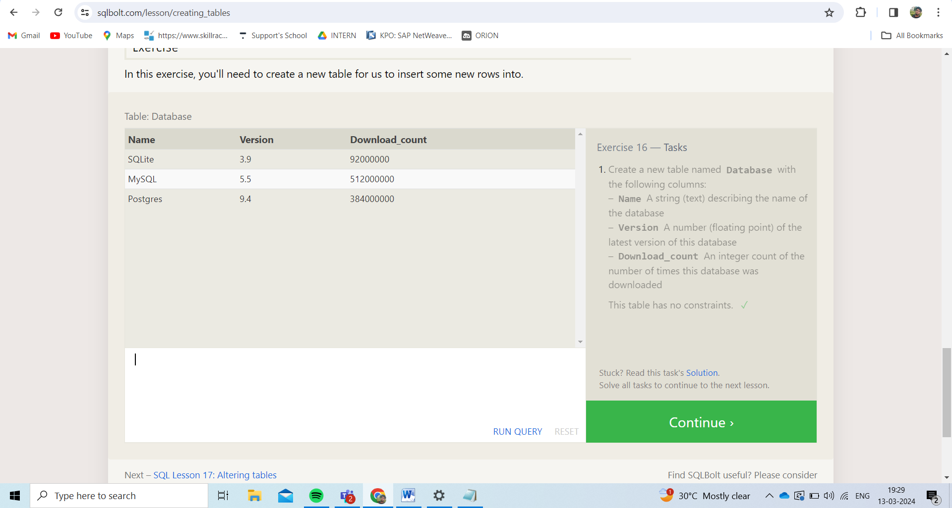

1. create table Database (

Name text,

Version float,

Download_count int

);

**SQL Lesson 17: Altering tables:**

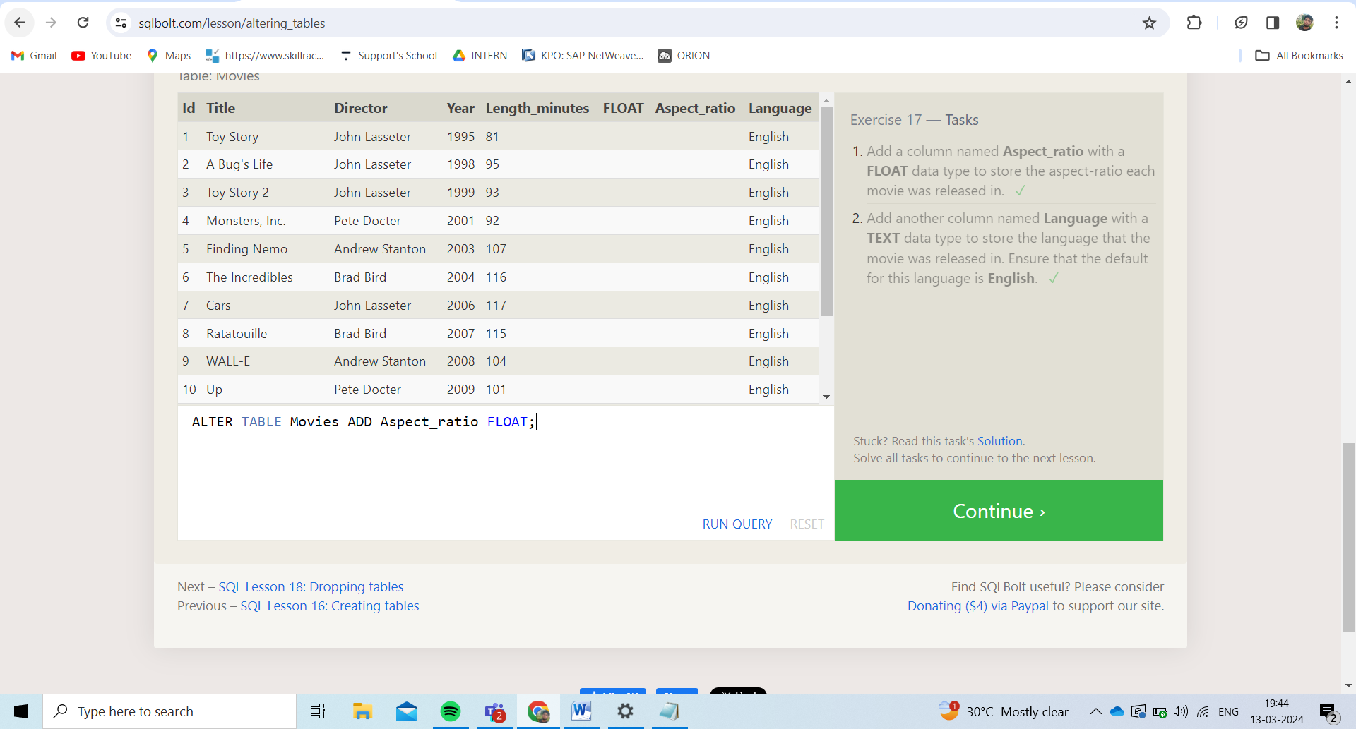

1. ALTER TABLE Movies ADD Aspect_ratio FLOAT;

2. ALTER TABLE Movies ADD Language Text default "English";

**SQL Lesson 18: Dropping tables:**

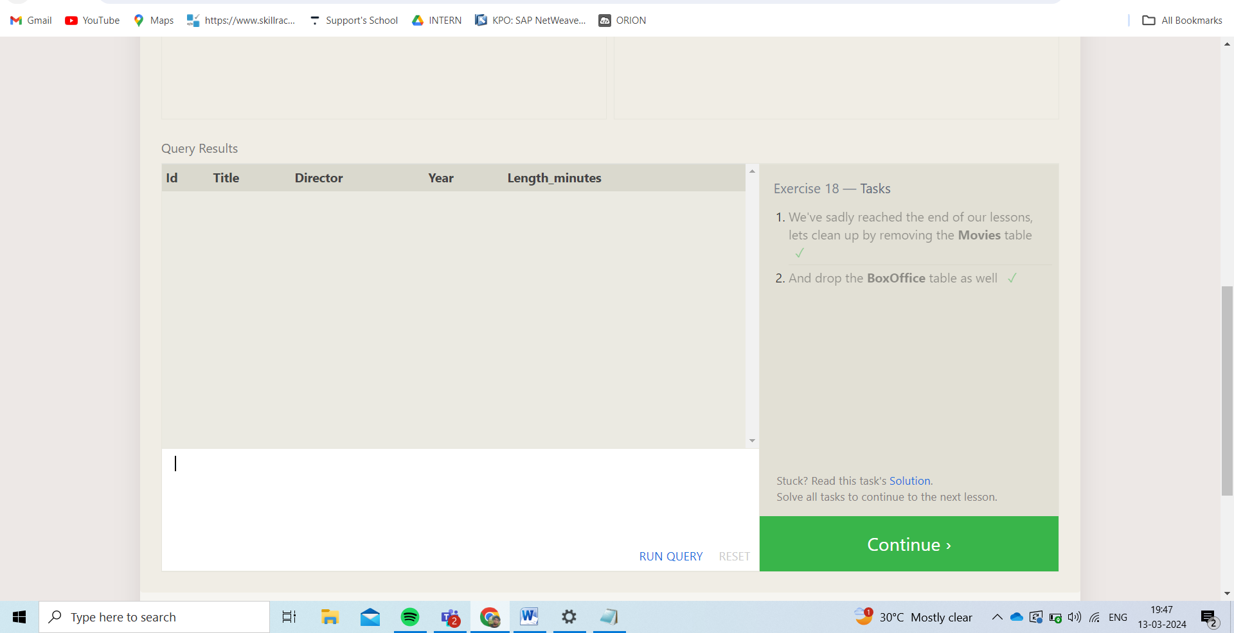

1. DROP TABLE IF EXISTS MOVIES ;
2. DROP TABLE IF EXISTS BOXOFFICE ;